Nexus Aquarium

User Guide

|  |  |  |
| --- | --- | --- |
| Center Name | Aptech Garden | |
| Batch | 2301D | |
| Semester | 1st Semester | |
| Faculty | Sir Azhar Ghafoor | |
| Project Name | Nexus Aquarium | |
| Serial No. | Enrollment | Student Name |
| 1 | 1445240 | M.Musharaf Wahab |
| 2 | 1444475 | Ali Muhammad |
| 3 | 1447514 | Imran Mala |

***User Guide***

1. **Top Layout:**

* Users can Register and Login their account from the upper Nav.
* Users can Navigate through different pages through the main Nav.

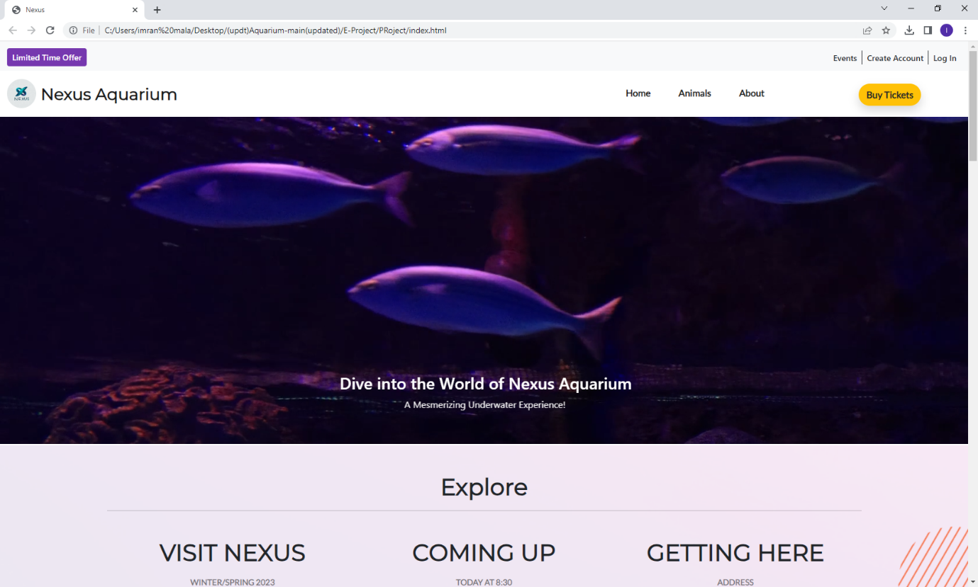

2. **Explore/Events:**

* Explore section contains basic information about Timings Tickets and Locations.
* Users can know about upcoming Events and Shows through Events Section.

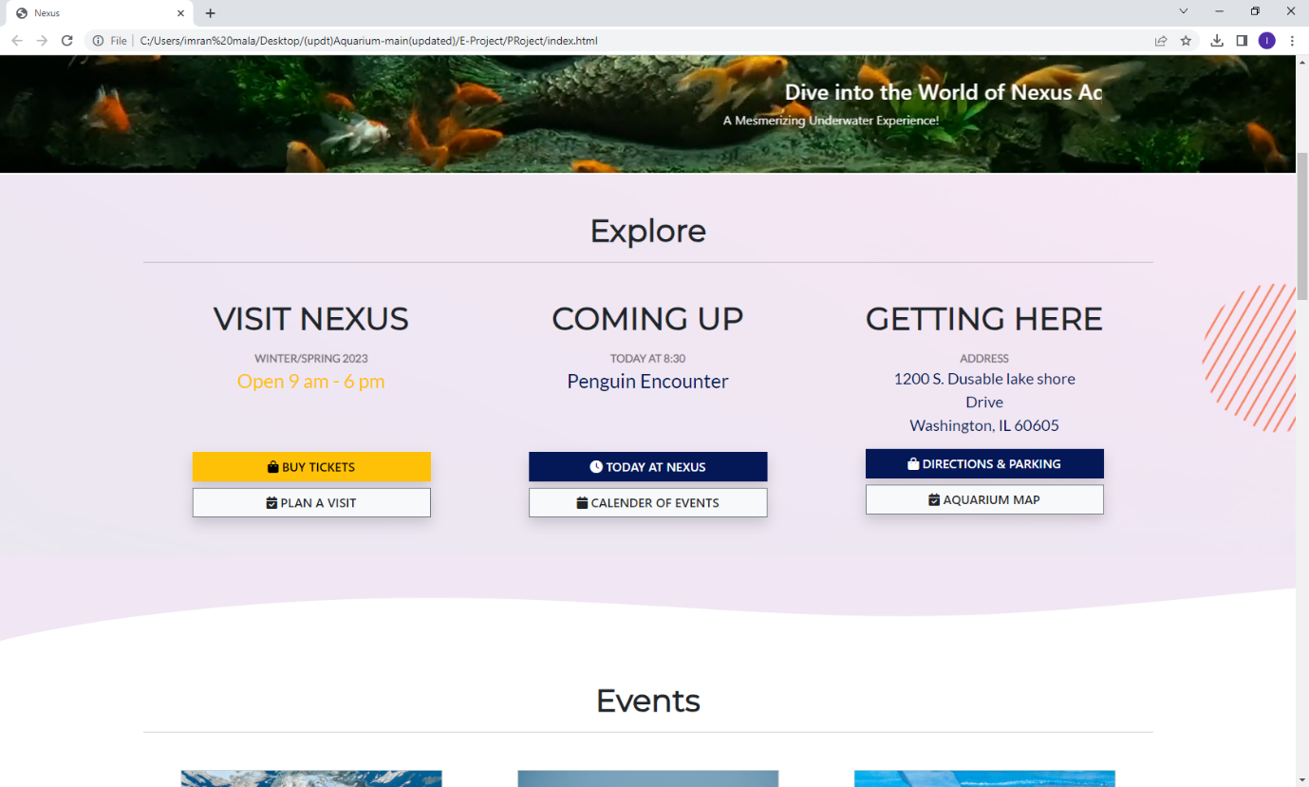

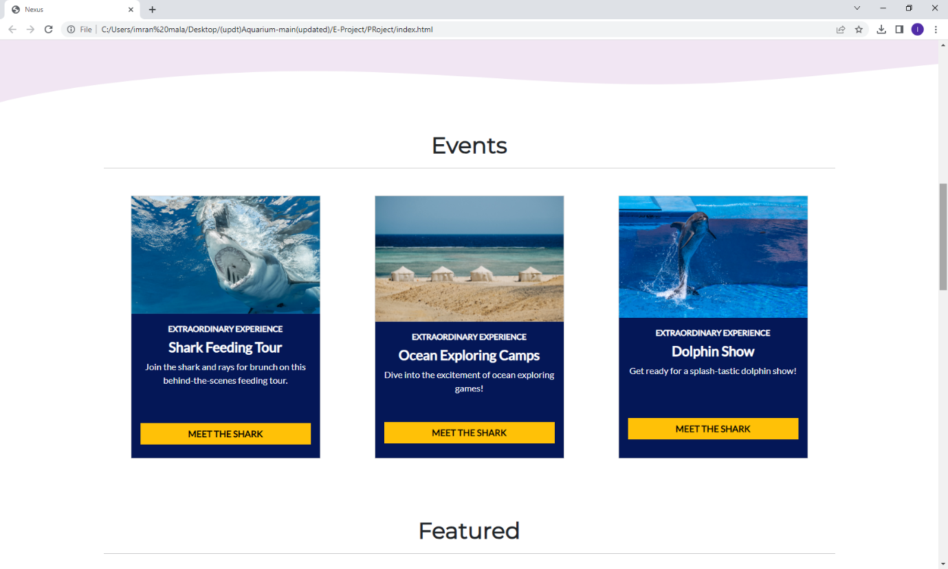

3. **Featured:**

* This section contains some of the rare animals we have at Nexus Aquarium.

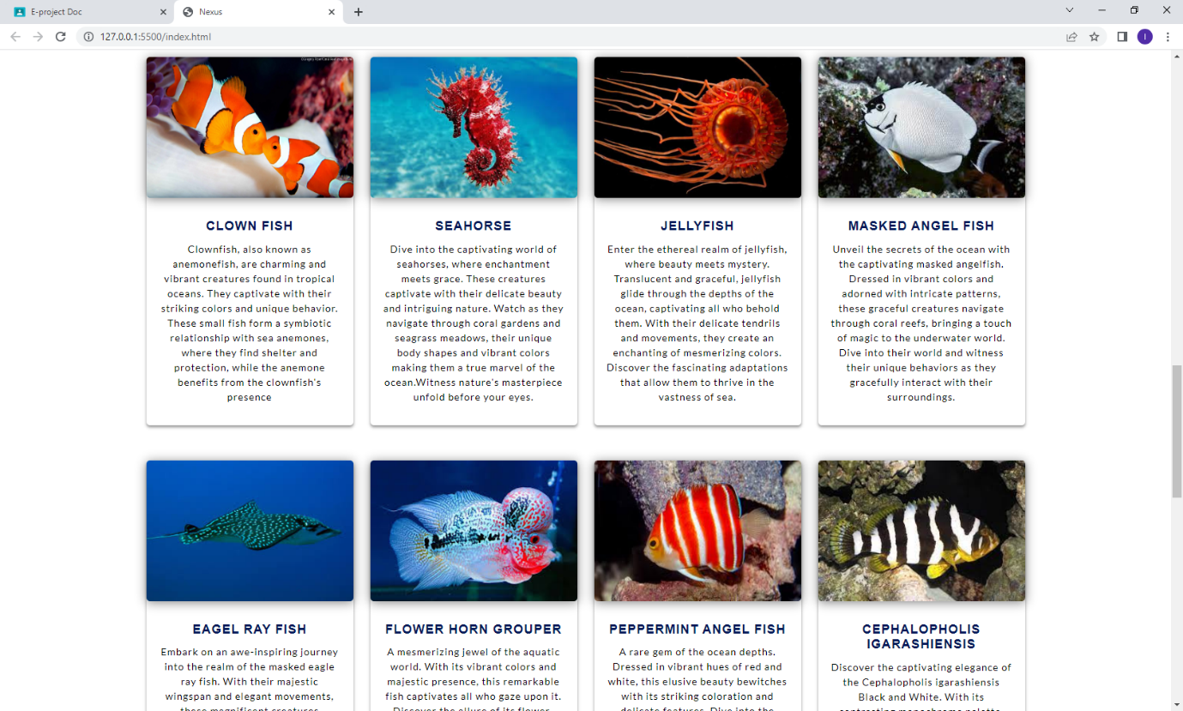

4. **Feedback:**

* Users can tell us about their experience with our Aquarium.

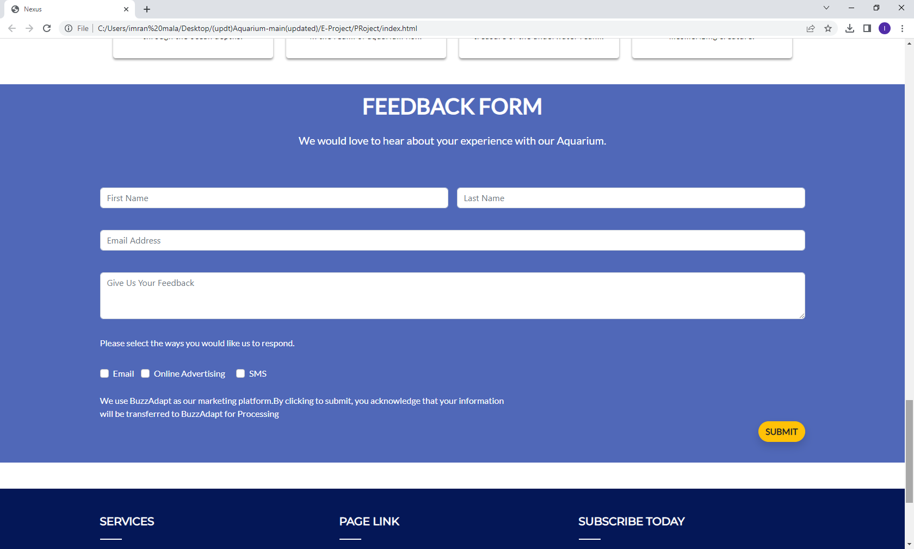

5. **Gallery Section:**

* We have categorized different kinds of Animals in this Section.
* Users can click on Buttons to see specific Animals.

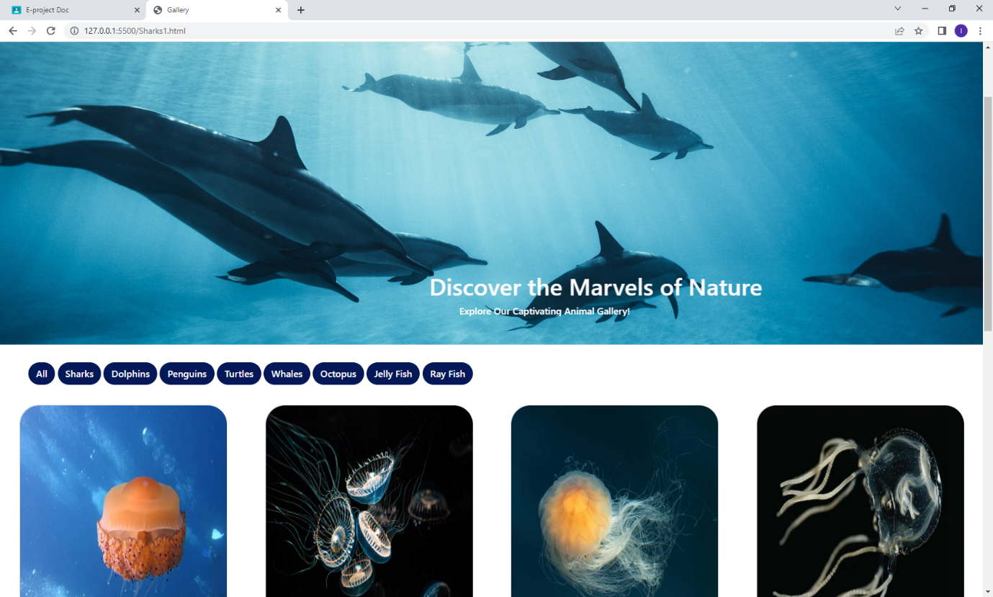

6. **About Us:**

* This page contains information about Values, Stories and Vison our Aquarium holds.

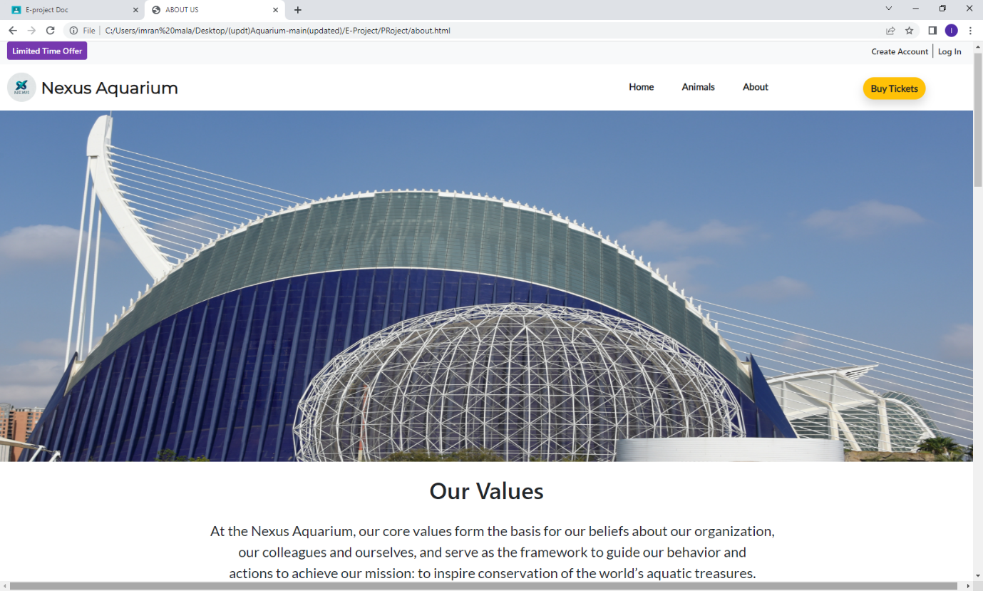

5. **Ticket Page:**

* Through this page uses can book their Tickets in advance.

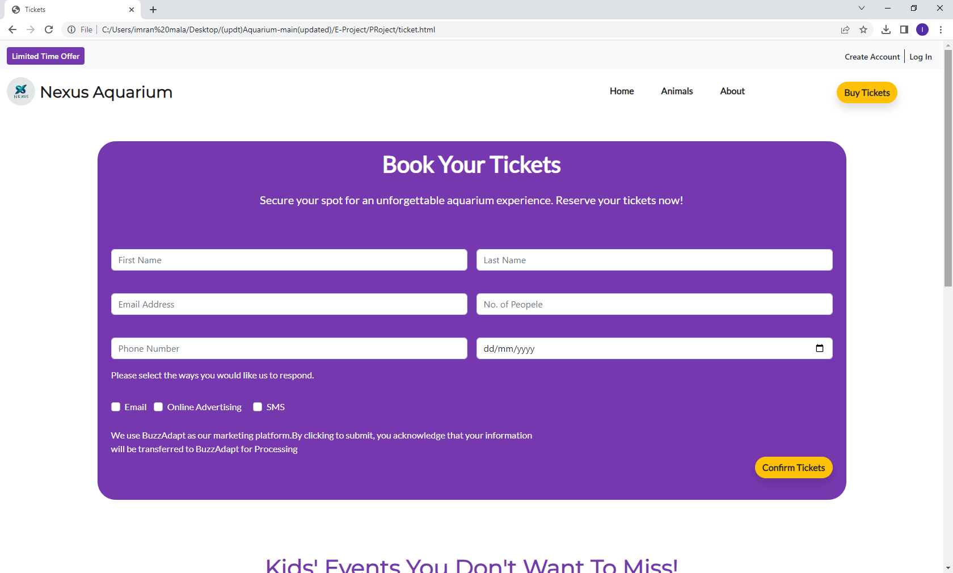

8. **Bottom Layout:**

* It has the links to all our Social Accounts.
* It also contains a Newsletter so that users remain up to date with our Aquarium.

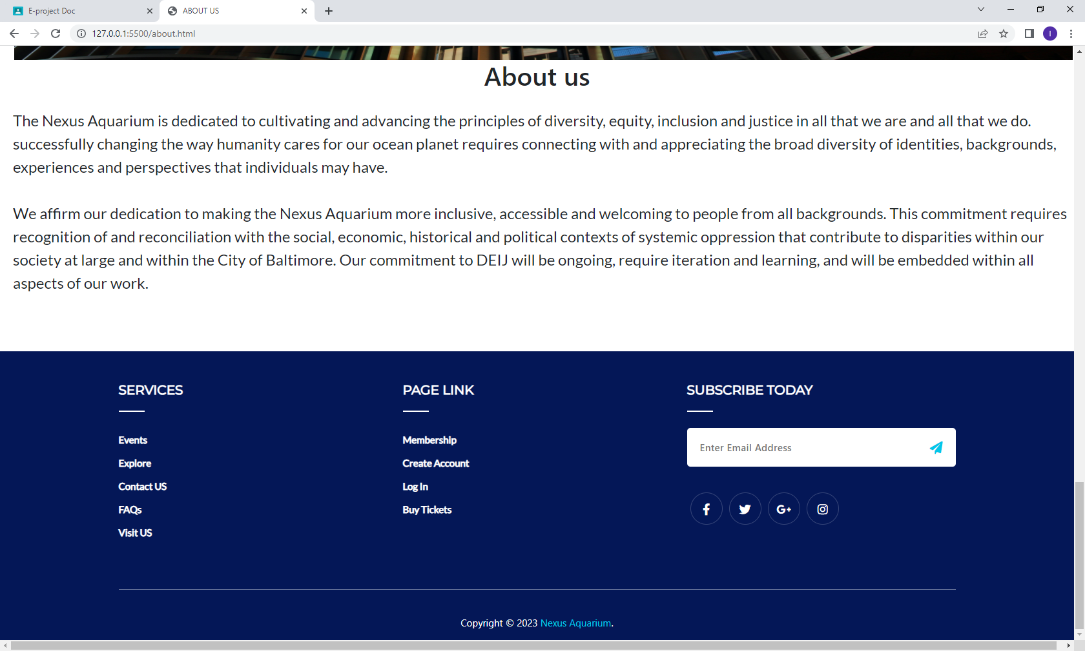

The End.